TASK 8:

**-- Task 8: Power BI Dashboard for Retail Insights**

**-- 1. Total Sales (Card Visual)**

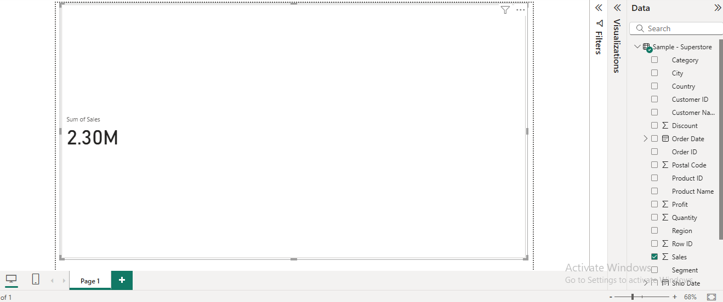

**-- 2. Top 5 Products by Sales (Bar Chart)**

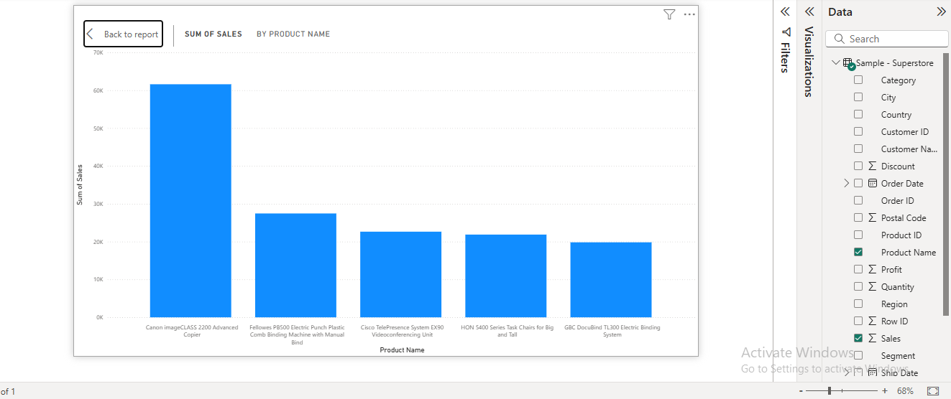

**-- 3. Sales by Region (Pie Chart)**

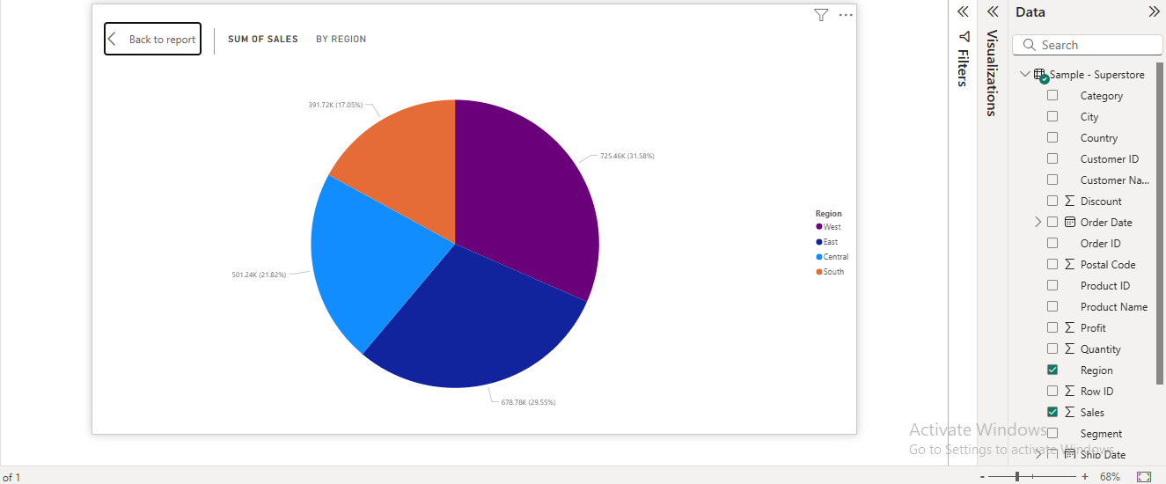

**-- 4. Monthly Sales Trend (Line Chart)**

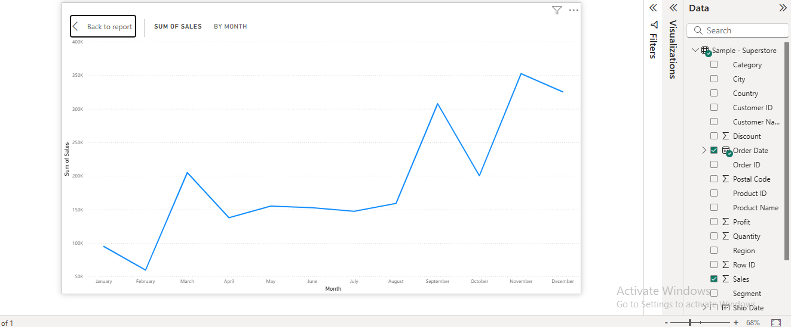

**-- 5. Slicers for Interactivity**

